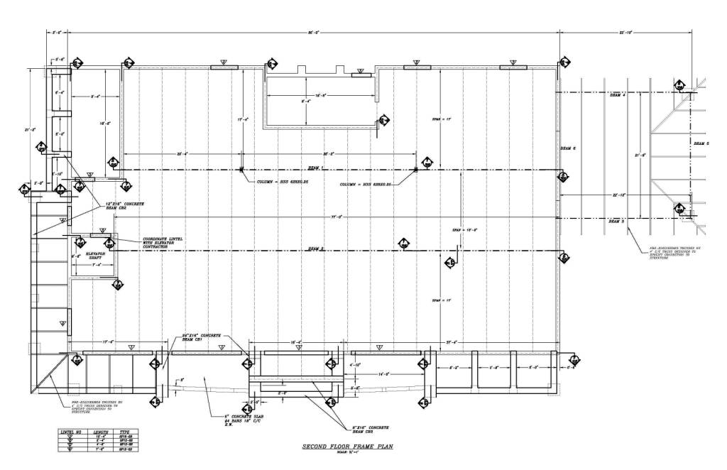

PLAN (BIRD’S EYE VIEW) TOP/DOWN SECTION

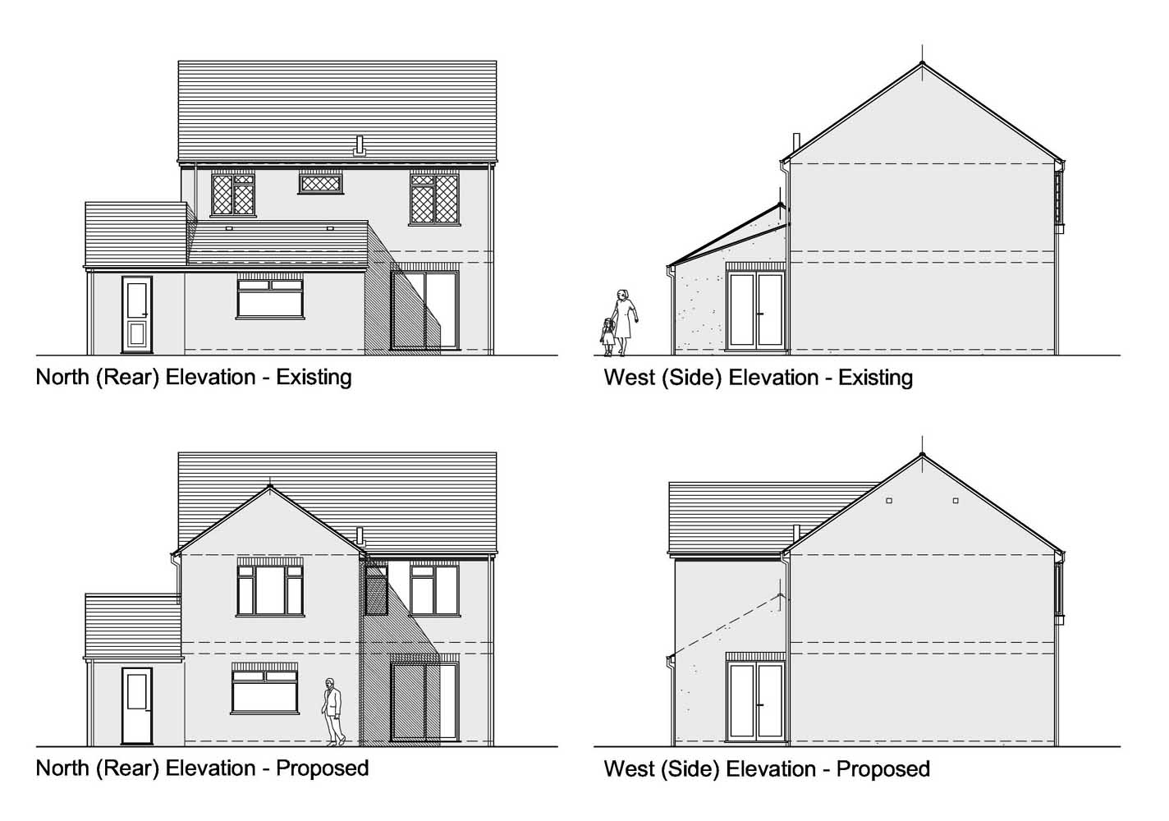

ELEVATION DETAILS 3-D COVER + COST

ARCHITECTURAL ELEVATIONS

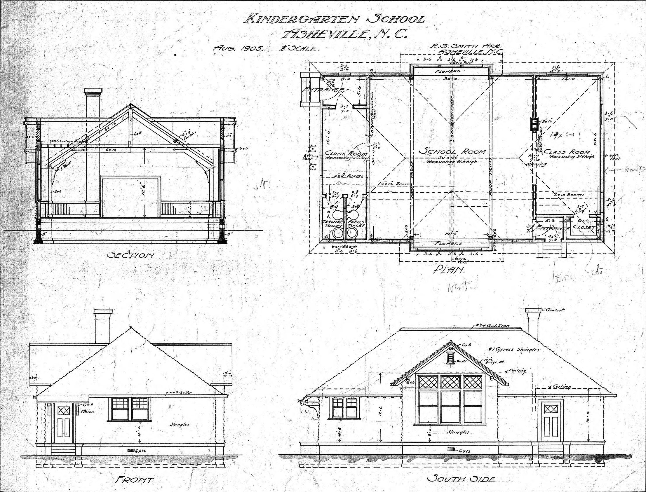

STAIRS

